21.To design DFA AB over end using automata softaware.

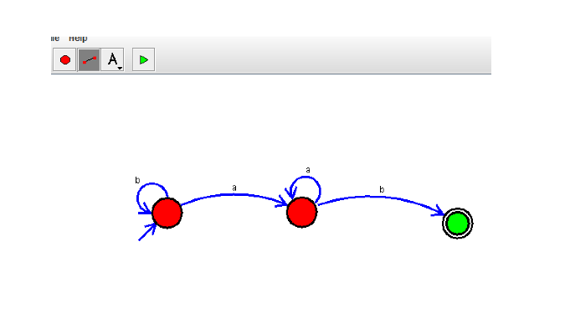

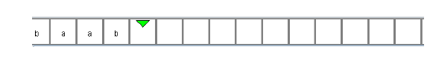

**Result:** Thus designing DFA AB over end is done and verified by giving sample inputs.